**WEEK-1**

**DESIGN PRINCIPLES AND PATTERNS**

**Exercise-1:Implementing the Singleton Pattern:**

**Code:**

**Logger.java:**

package example;

public class Logger {

private volatile static Logger instance;

private Logger(){

System.out.println("Instance created");

}

public static Logger getInstance(){

if(instance==null){

synchronized(Logger.class) {

if(instance==null) {

instance=new Logger();

}

}

}

return instance; }}

**TestClass.java:**

package example;

public class TestClass {

public static void main(String args[]) {

Logger l1=Logger.getInstance();

Logger l2=Logger.getInstance();

if(l1==l2){

System.out.println("Both are the same instances");

}

else{

System.out.println("Both are different instances");

}

}

}

**Output:**

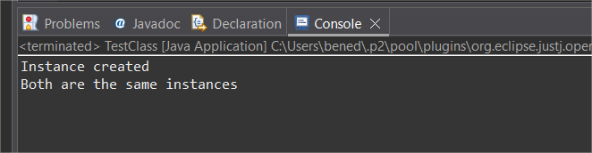

**Exercise-2:Implementing the Factory Method Pattern:**

**Code:**

**Document.java:**

package example;

public interface Document {

void open();

}

**WordDocument.java:**

package example;

public class WordDocument implements Document{

public void open() {

System.out.println("Opening a WORD document");

}

}

**PdfDocument.java:**

package example;

public class PdfDocument implements Document{

public void open() {

System.out.println("Opening a PDF document");

}}

**ExcelDocument.java:**

package example;

public class ExcelDocument implements Document{

public void open() {

System.out.println("Opening an EXCEL document");

}

}

**DocumentFactory.java**

package example;

public abstract class DocumentFactory {

public abstract Document createDocument();

}

**WordDocumentFactory.java**

package example;

public class WordDocumentFactory extends DocumentFactory{

public Document createDocument() {

return new WordDocument();

}

}

**PdfDocumentFactory.java**

package example;

public class PdfDocumentFactory extends DocumentFactory{

public Document createDocument() {

return new PdfDocument();

}

}

**ExcelDocumentFactory.java**

package example;

public class ExcelDocumentFactory extends DocumentFactory{

public Document createDocument() {

return new ExcelDocument();

}

}

**Main.java**

package example;

public class Main {

public static void main(String args[]) {

DocumentFactory word_factory=new WordDocumentFactory();

Document word=word_factory.createDocument();

word.open();

DocumentFactory pdf_factory=new PdfDocumentFactory();

Document pdf=pdf_factory.createDocument();

pdf.open();

DocumentFactory excel_factory=new ExcelDocumentFactory();

Document excel=excel_factory.createDocument();

excel.open();}}

**Output:**

